AWS WAF (Web Application Firewall)

AWS WAF (Web Application Firewall) is a security service that protects our web applications from common web attacks such as SQL Injection, Cross-Site Scripting (XSS), bots, and DDoS layer-7 attacks.
Imagine you have an online shopping website.
Without WAF:
User
│
▼
Website
A hacker can directly send malicious requests.
With WAF:
User
│
▼
AWS WAF
│
▼
Website
AWS WAF checks every request first.

What attacks does AWS WAF protect against?

1. SQL Injection (SQLi)

What is SQL Injection?
A hacker tries to execute SQL commands through your application's input fields.

2. Cross-Site Scripting (XSS)
Suppose your website allows comments.
Normal comment: Nice Product!
Attacker enters:
<script>
alert("Hacked");
</script>
If stored,
Every visitor executes that script.
AWS WAF detects suspicious JavaScript and blocks it.

3. Bot Protection
Bots can:
- Create fake accounts
- Scrape product prices
- Try thousands of passwords
- Overload the server
AWS WAF Bot Control identifies and blocks malicious bots.

4. HTTP Flood Attack
Thousands of HTTP requests:
Request 1
Request 2
Request 3
...
Request 1,00,000
Server becomes busy.
AWS WAF Rate-Based Rules can limit requests from the same IP.
Example:
Allow only 1000 requests
per 5 minutes
from one IP.

If exceeded,WAF blocks further requests.

Components of AWS WAF
There are four main components.

Web ACL
│
├── Rules
│ │
│ ├── Rule Groups
│ └── Conditions

Where can AWS WAF be attached?
AWS WAF can protect several AWS services.
Internet
│
▼
AWS WAF
│
┌─────────────┐
│CloudFront │
│ALB │
│API Gateway │
│AppSync │
└─────────────┘
│
▼
Application
AWS WAF can be associated with:
- Application Load Balancer (ALB)
- CloudFront Distribution
- API Gateway
- AppSync

Protect an Nginx Web Server using AWS WAF

Objective
Deploy an Nginx web server on EC2 and protect it from common web attacks using AWS WAF attached to an Application Load Balancer (ALB).

Prerequisites
- AWS Account
- IAM user with EC2, ELB, WAF, and VPC permissions
- One VPC
- Two Public Subnets (different Availability Zones)
- Internet Gateway attached
- Security Group allowing:
  - HTTP (80)
  - SSH (22)

Task 1: Launch an EC2 Instance and Install Nginx

Step 1
Launch an EC2 Instance
- Amazon Linux 2023
- t2.micro / t3.micro
- Public IP Enabled
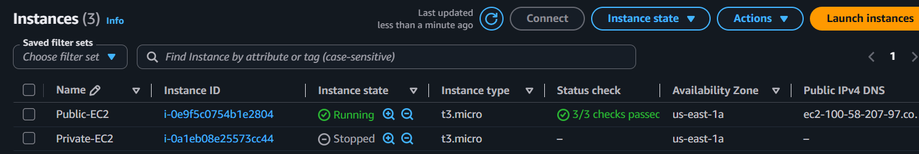

Step 2
Connect to EC2
ssh -i key.pem ec2-user@Public-IP

Step 3
Install Nginx
sudo dnf update -y
sudo dnf install nginx -y
sudo systemctl enable nginx
sudo systemctl start nginx

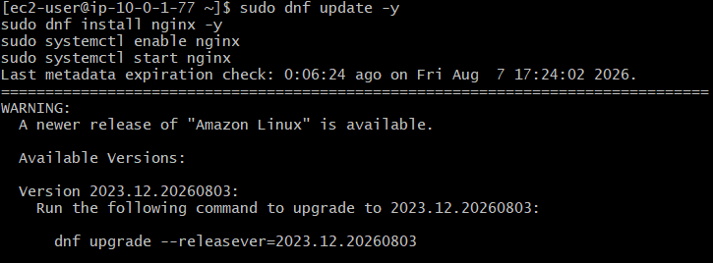

Step 4
Verify
systemctl status nginx
Expected
active (running)
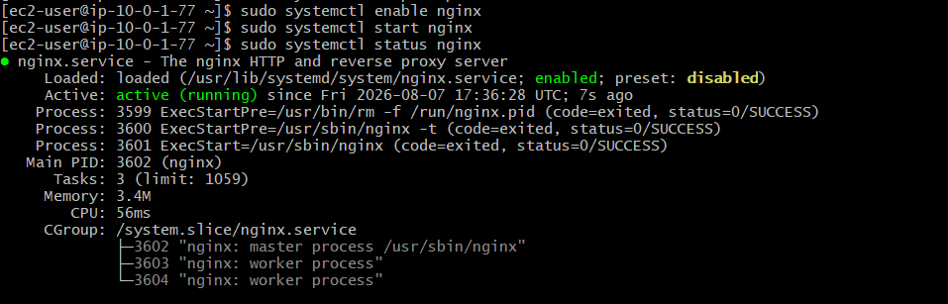

Step 5
Open Browser
http://EC2-Public-IP
You should see
Welcome to nginx!
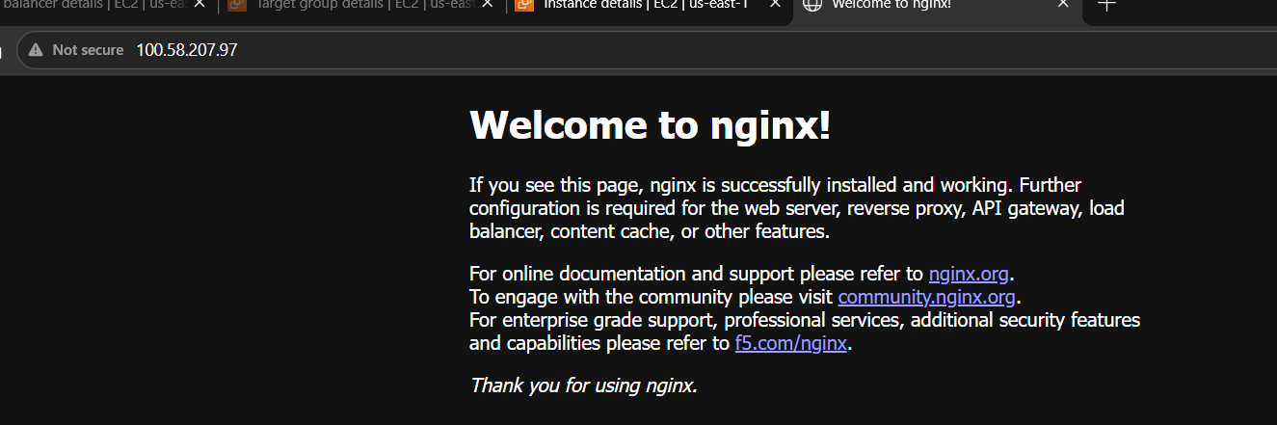

Task 2: Create an Application Load Balancer

Step 1
Go to
EC2
→ Load Balancers
→ Create Load Balancer
→ Application Load Balancer
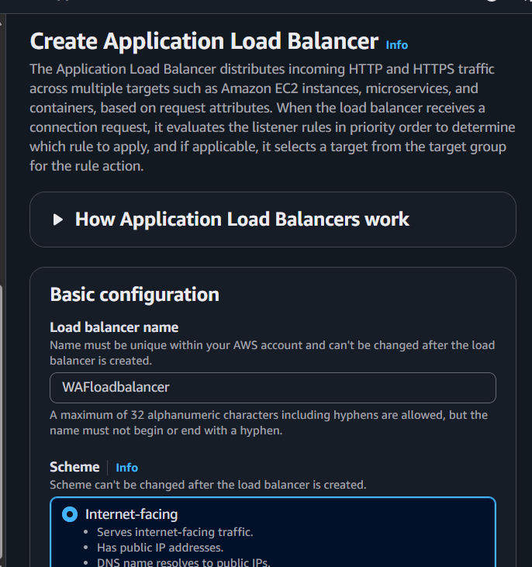

Step 2
Configure
- Internet Facing
- IPv4
- Listener: HTTP (80)

Step 3
Select
- VPC
- Two Public Subnets
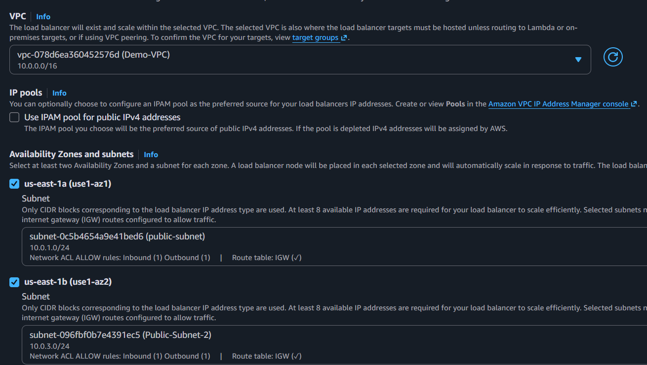

Step 4
Security Group
Allow
HTTP 80
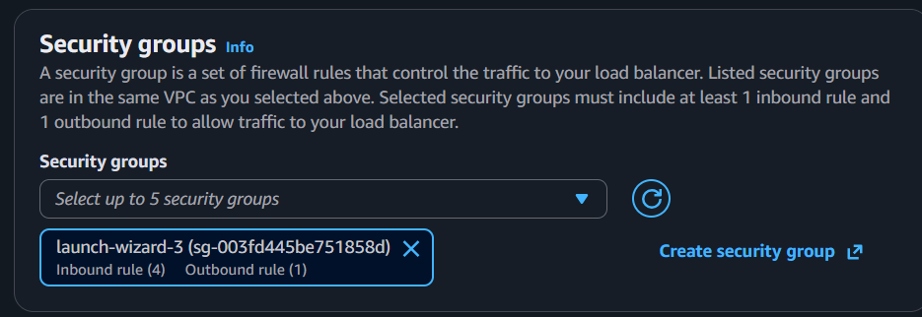

Step 5
Create Target Group
Type
Instances
Protocol
HTTP
Port
80

Step 6
Register EC2 Instance
Wait until
Healthy
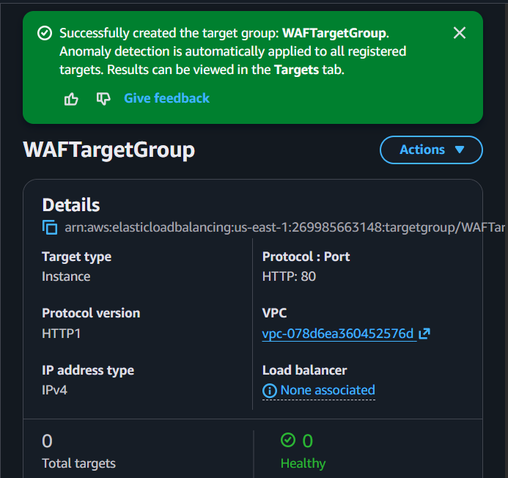

Step 7
Create ALB
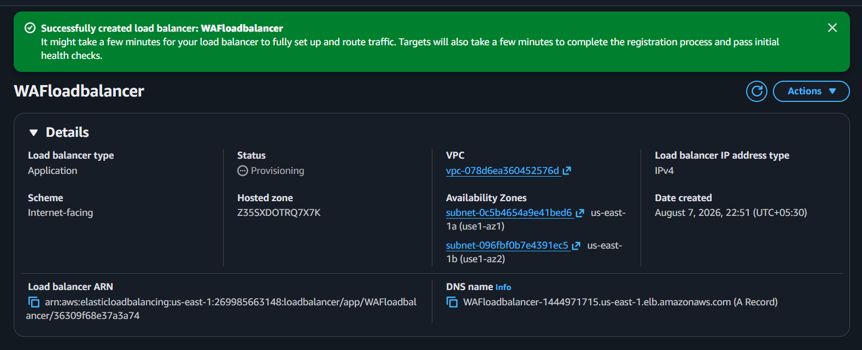
Copy
DNS Name
Open Browser
http://ALB-DNS
Nginx page should load.
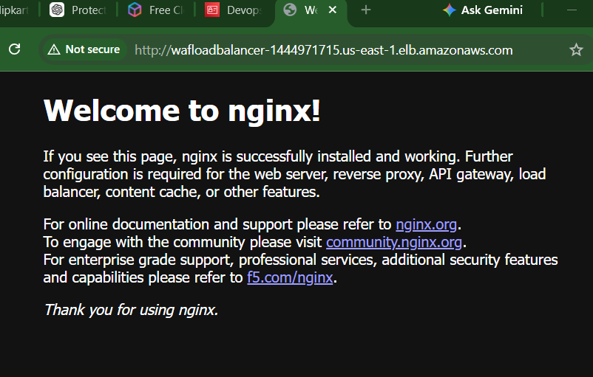

Task 3: Create AWS WAF Web ACL

Step 1
Go to
AWS WAF & Shield

Step 2
Click
Create Web ACL

Step 3
Configuration
Name
Nginx-WebACL
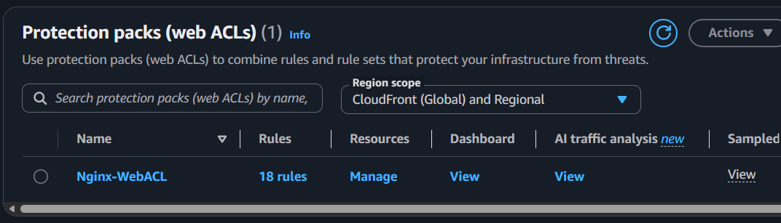
Region
Same as ALB
Resource Type
Regional Resources
Associate Resource
Application Load Balancer
Select your ALB.

Step 4
Add Managed Rules
Click
Add Rules
↓
Add Managed Rule Groups
Add these AWS managed rule groups:
- AWSManagedRulesCommonRuleSet
- AWSManagedRulesKnownBadInputsRuleSet
- AWSManagedRulesSQLiRuleSet
- AWSManagedRulesLinuxRuleSet
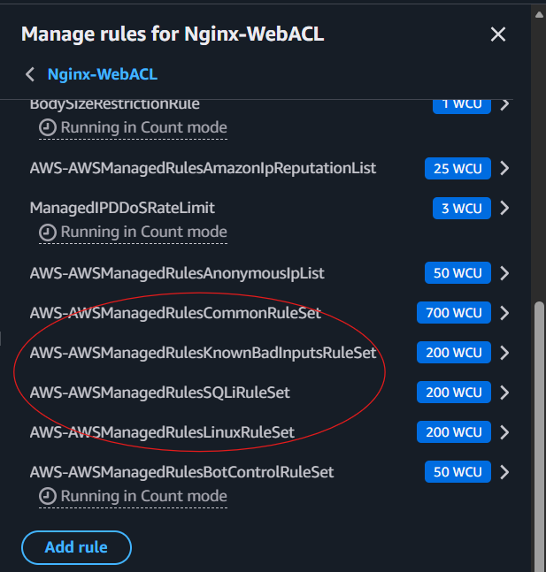
Action
Block

Step 5
Create Web ACL
Wait 2–3 minutes for deployment.

Task 4: Test SQL Injection Protection
Open Browser
http://ALB-DNS/?id=' OR 1=1--
Expected
403 Forbidden
The request is blocked by AWS WAF.
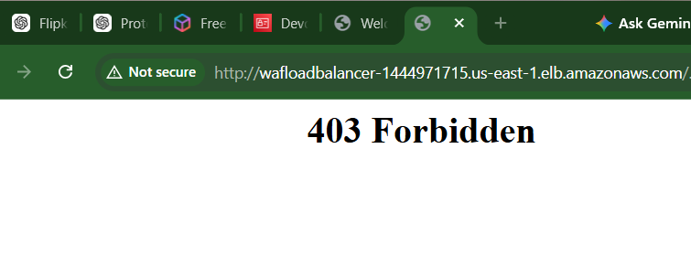

Task 5: Test Cross-Site Scripting (XSS)
Open
http://ALB-DNS/?name=<script>alert(1)</script>
Expected
403 Forbidden
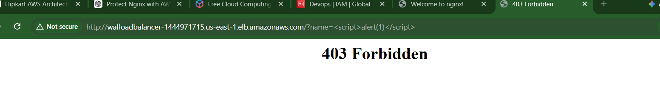

Task 6: Test Bad Inputs
Try
http://ALB-DNS/?cmd=../../etc/passwd
Expected
403 Forbidden
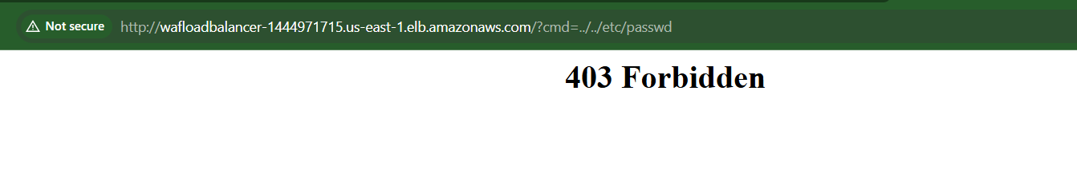

Task 7: Enable WAF Logging
- Open your Web ACL.
- Go to the Logging and metrics tab.
- Click Enable logging.
- Choose an Amazon CloudWatch Logs log group (or create a new one).
- Save the configuration.
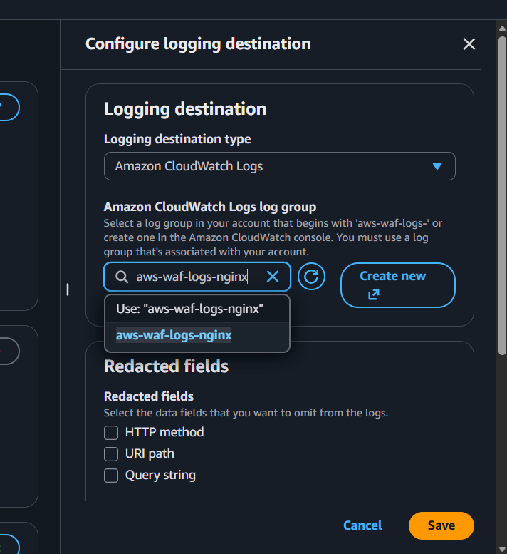
After enabling logging, send a few test requests to the ALB.

Task 8: Verify WAF Metrics
Go to:
CloudWatch
→ Metrics
→ WAFV2
Verify metrics such as:
- Allowed Requests
- Blocked Requests
- Counted Requests
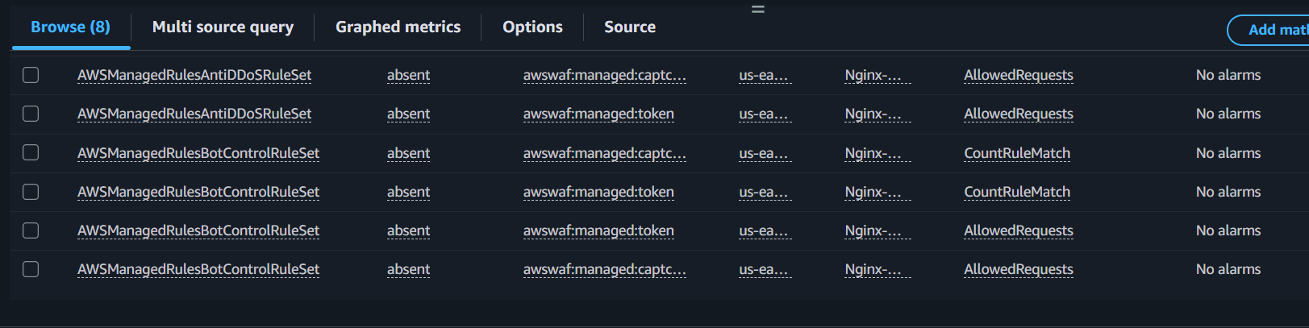
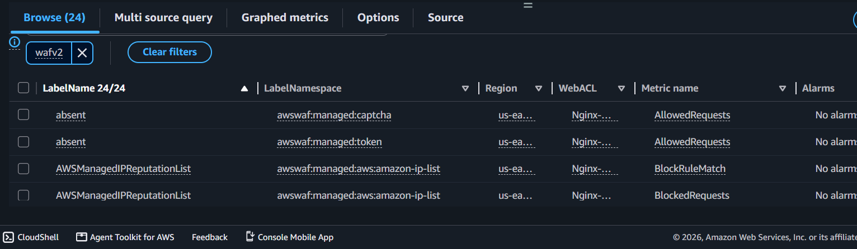
You should see blocked requests increase after your tests.
System Manager

AWS Systems Manager (SSM) is an AWS service that helps you manage, monitor, automate, and securely operate your AWS resources (EC2 instances, on-premises servers, edge devices, and some multi-cloud resources) from a single place.

Key Features of AWS Systems Manager
- Session Manager
  - Securely connect to EC2 instances without opening SSH (port 22) or RDP (port 3389).
  - Uses IAM for access control.
  - Supports session logging to CloudWatch Logs or S3.
- Parameter Store
  - Store configuration values such as:
    - Database connection strings
    - API keys
    - Passwords (encrypted with KMS)
  - Retrieve parameters securely from applications.
- Run Command
  - Execute commands on one or many managed instances without logging in.
  - Example:
    - Restart a service
    - Install software
    - Collect logs
- Patch Manager
  - Automate operating system patching.
  - Schedule maintenance windows.
  - Generate compliance reports.
- Automation
  - Automate common operational tasks using predefined or custom runbooks.
  - Examples:
    - Start/stop EC2 instances
    - Create AMI backups
    - Remediate security findings
- Inventory
  - Collect software, hardware, and application inventory from managed instances.
- State Manager
  - Keep instances in a desired configuration.
  - Example:
    - Ensure a specific package is always installed.
    - Ensure a service is always running.
- Maintenance Windows
  - Schedule maintenance tasks like patching, backups, and updates during approved time windows.

How AWS Systems Manager Works
- Install the SSM Agent on the instance (Amazon Linux and many recent AWS AMIs include it by default).
- Attach an IAM role with Systems Manager permissions (commonly the AmazonSSMManagedInstanceCore managed policy).
- The instance communicates securely with the Systems Manager service.
- Administrators manage the instance through the AWS Management Console, AWS CLI, or SDKs.

Benefits
- No need to expose SSH or RDP ports.
- Centralized management of thousands of servers.
- Improved security using IAM and encryption.
- Automated patching and maintenance.
- Reduced operational overhead.

Common Use Cases
- Remote access to EC2 instances without SSH.
- Secure storage of application configuration and secrets.
- Automated OS patching.
- Running scripts across multiple servers.
- Collecting inventory and compliance data.
- Scheduling routine maintenance.

Example Architecture
Administrator
│
▼
AWS Systems Manager
│
▼
SSM Agent
│
▼
EC2 Instance(s)

Task: EC2 Remote Management and Configuration Using AWS Systems Manager
Objective:
Use AWS Systems Manager to remotely execute commands, install software, and verify the configuration of an EC2 instance without SSH.

What you will implement
AWS Systems Manager
│
┌────────────┼────────────┐
↓ ↓ ↓
Session Manager Run Command Parameter Store
│ │
└────────────┼────────────┘
↓
EC2
│
┌────────┴────────┐
↓ ↓
Nginx Configuration

Task Steps

Part 1: Create the EC2 Instance

Step 1: Open EC2
Go to:
AWS Console → EC2 → Instances → Launch instances

Step 2: Configure the instance
Use:
Setting | Value
Name | SSM-Lab-Server
AMI | Amazon Linux 2023
Instance type | t3.micro
Key pair | Optional for this task
VPC | Default VPC
Subnet | Any available subnet
Auto-assign Public IP | Enabled

Step 3: Security Group
For this task, you do not need SSH port 22.
You can leave the security group without an inbound SSH rule.
This is one of the advantages of Session Manager.
For testing Nginx from the internet, you can temporarily add:
Type: HTTP
Port: 80
Source: 0.0.0.0/0

Step 4: Launch
Click:
Launch instance
Wait until the instance reaches:
Instance state: Running
Status check: 2/2 checks passed

Part 2: Create IAM Role for Systems Manager
The EC2 instance needs permission to communicate with Systems Manager.

Step 5: Open IAM
Go to:
IAM → Roles → Create role

Step 6: Select trusted entity
Choose:
Trusted entity type:
AWS service
For service:
EC2
Click Next.

Step 7: Add permission
Search for:
AmazonSSMManagedInstanceCore
Select:
AmazonSSMManagedInstanceCore
Click Next.

Step 8: Name the role
Use:
SSM-EC2-Role
Click:
Create role
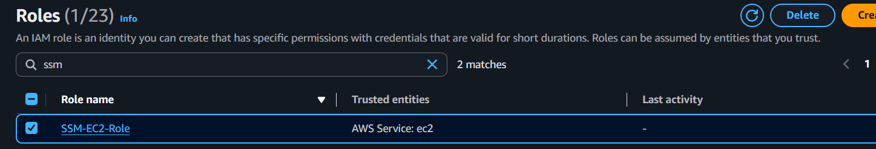

Part 3: Attach IAM Role to EC2

Step 9: Go back to EC2
Go to:
EC2 → Instances
Select:
SSM-Lab-Server
Then:
Actions → Security → Modify IAM role

Step 10: Select the role
Choose:
SSM-EC2-Role
Click:
Update IAM role
Now EC2 has permission to communicate with Systems Manager.
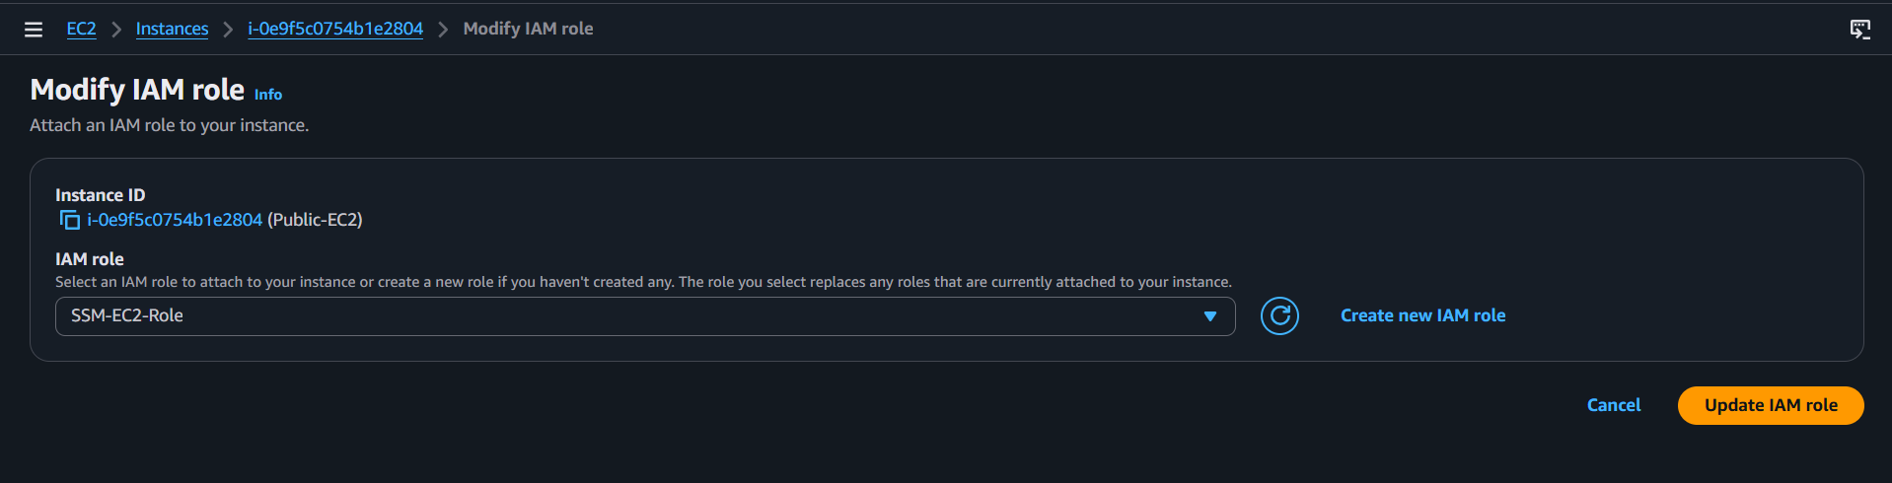

Part 4: Verify the EC2 Instance in Systems Manager

Step 11: Open Systems Manager
Go to:
AWS Console → Systems Manager
In the left navigation, find:
Node Tools → Fleet Manager
or
Node Tools → Managed nodes
Depending on the current console layout.

Step 12: Check your instance
You should see:
SSM-Lab-Server
Status: Online
If it shows Online, your instance is successfully registered with Systems Manager.
If it does not appear, wait a few minutes and check again.
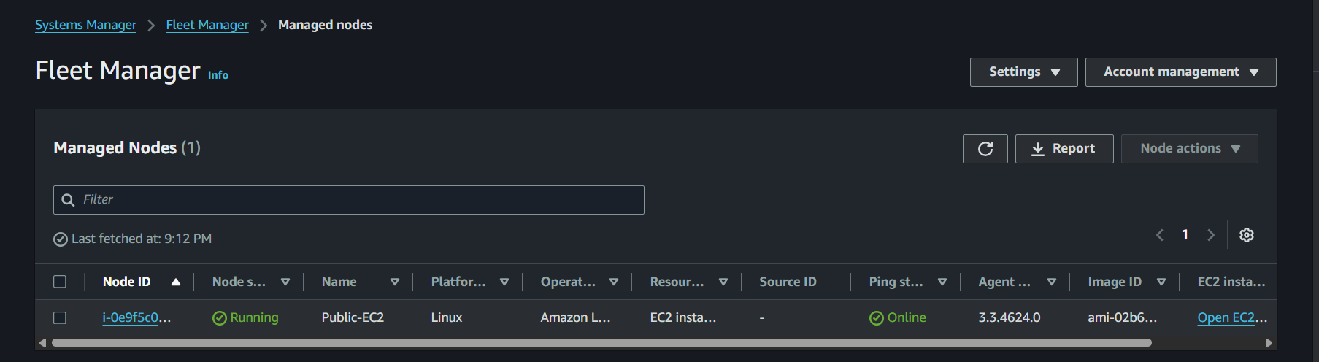

Part 5: Connect Using Session Manager
Now we will connect to EC2 without SSH.

Step 13: Open Session Manager
Go to:
Systems Manager → Node Tools → Session Manager
Click:
Start session

Step 14: Select the instance
You should see:
SSM-Lab-Server
Select it.
Click:
Start session
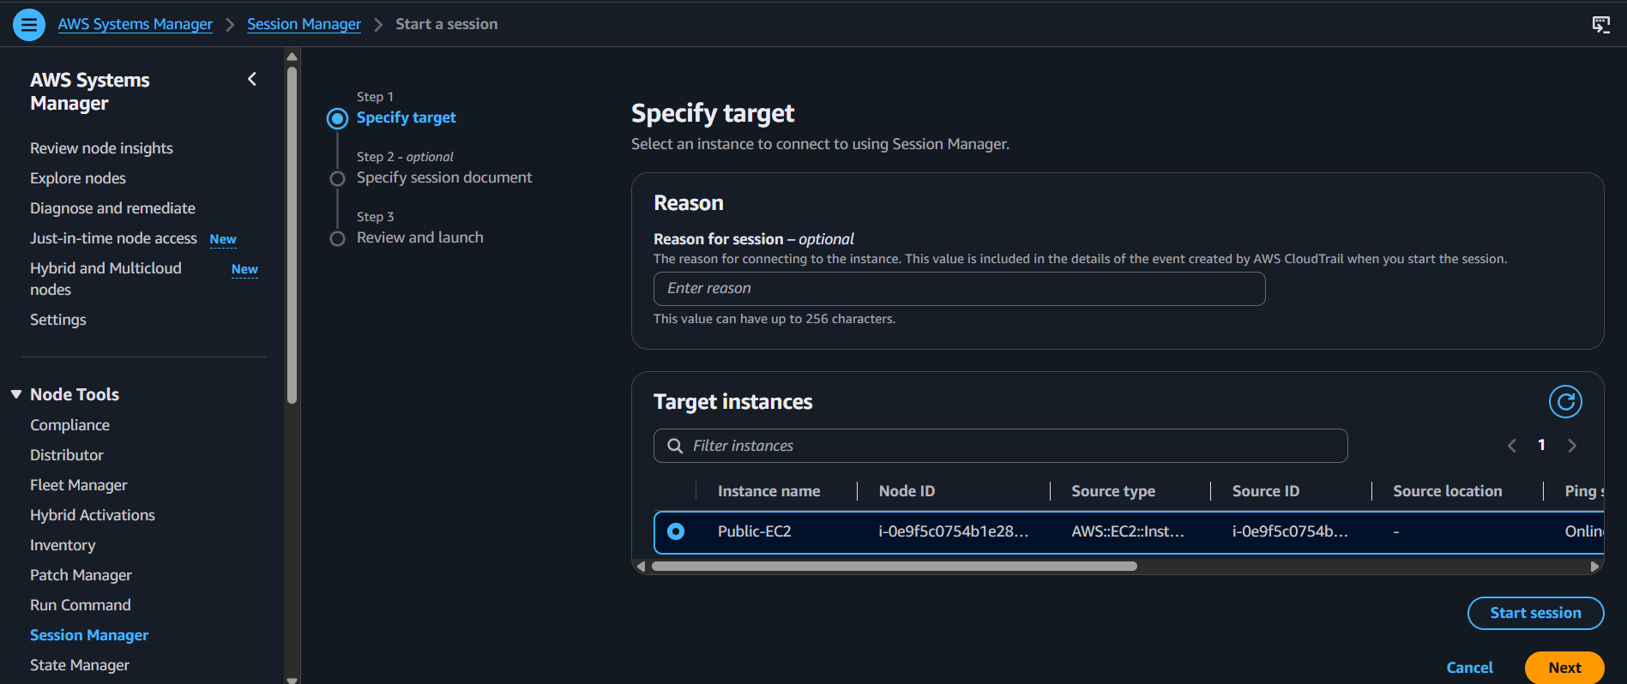

Step 15: Terminal opens
A browser-based terminal will open.
You may see something similar to:
sh-5.2$
You are now connected to your EC2 instance.
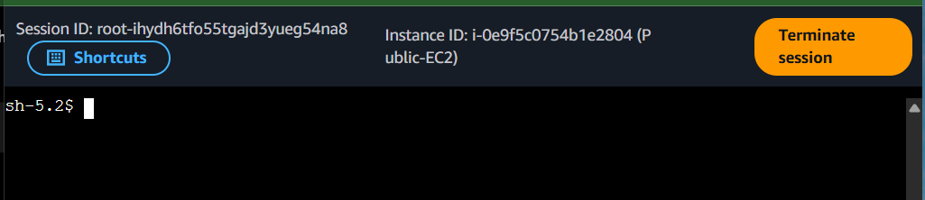

Step 16: Test the connection
Run:
whoami
Then:
hostname
Then:
uname -a
You should receive information about your EC2 instance.
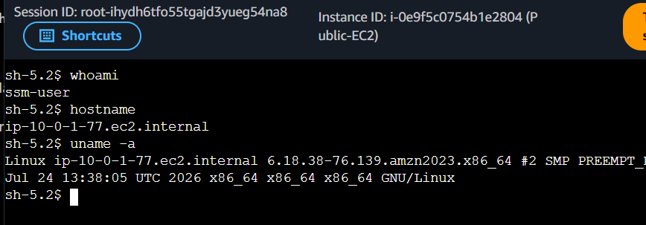

Important
Normally you might use:
ssh -i key.pem ec2-user@<IP>
But in this task, you are not using SSH.
The connection is:
Your Browser
↓
AWS Systems Manager
↓
SSM Agent
↓
EC2

Part 6: Use Run Command
Now we will execute commands remotely through Systems Manager.
You can even do this without opening a Session Manager terminal.

Step 17: Open Run Command
Go to:
Systems Manager → Node Tools → Run Command
Click:
Run command

Step 18: Select document
Search for:
AWS-RunShellScript
Select:
AWS-RunShellScript
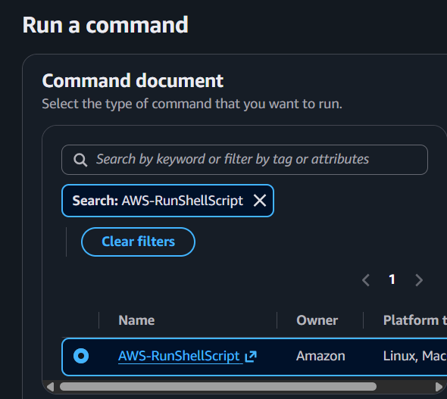

Part 7: Install Nginx Remotely

Step 19: Enter the command
Under Command parameters, enter:
sudo dnf install nginx -y
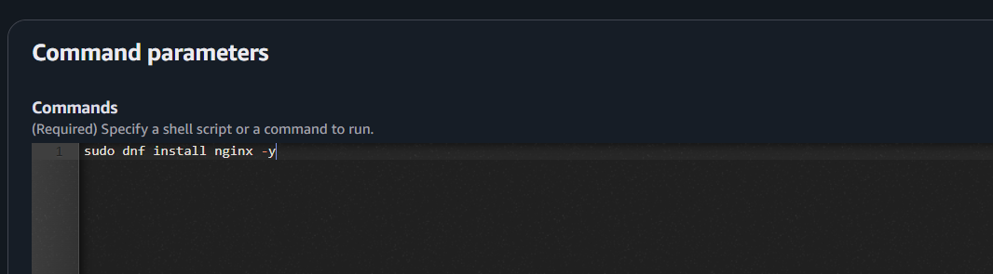

Step 20: Select target
Under Targets, choose:
Specify instance tags
or select the managed instance directly if available.
Select:
SSM-Lab-Server
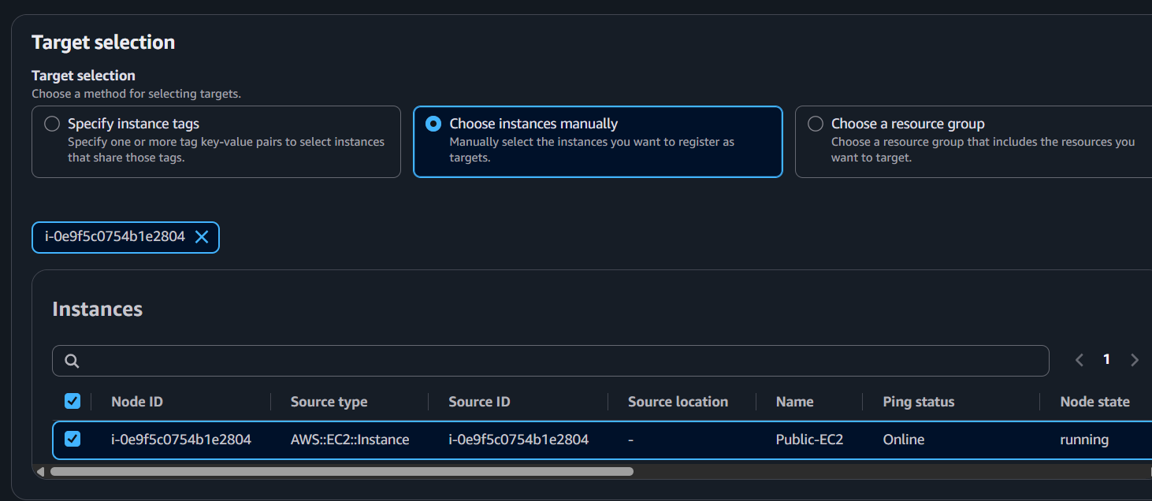

Step 21: Run the command
Click:
Run
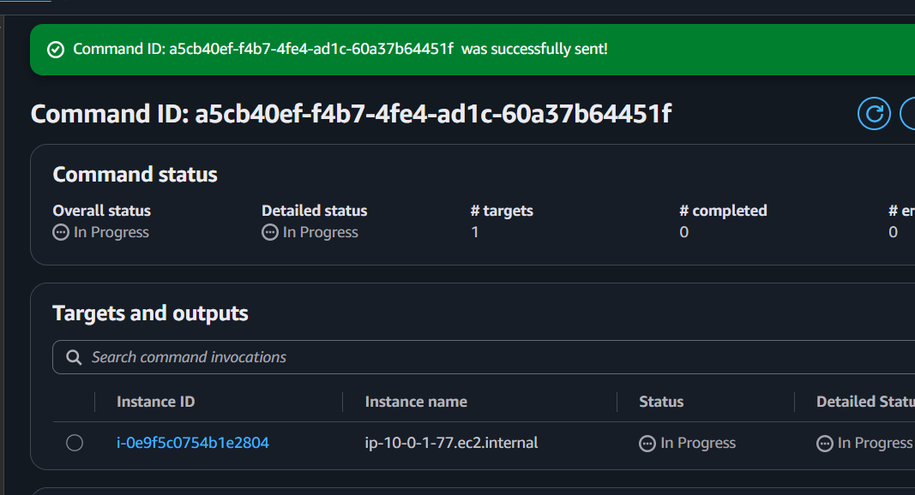
Systems Manager sends the command to the EC2 instance.
The flow is:
AWS Console
↓
Run Command
↓
SSM Agent
↓
EC2
↓
dnf install nginx

Part 8: Start Nginx
Run another Run Command.
Select:
AWS-RunShellScript
Enter:
sudo systemctl start nginx
sudo systemctl enable nginx
Click:
Run
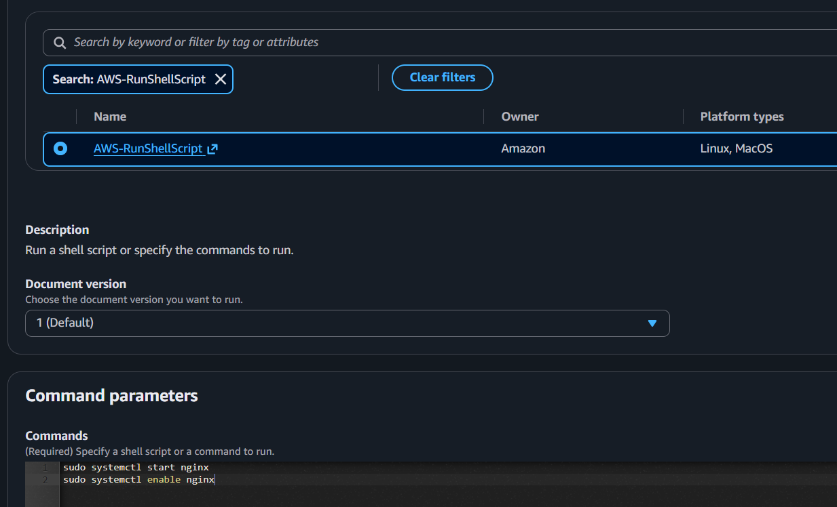

Part 9: Verify Nginx
Create another Run Command.
Use:
systemctl status nginx
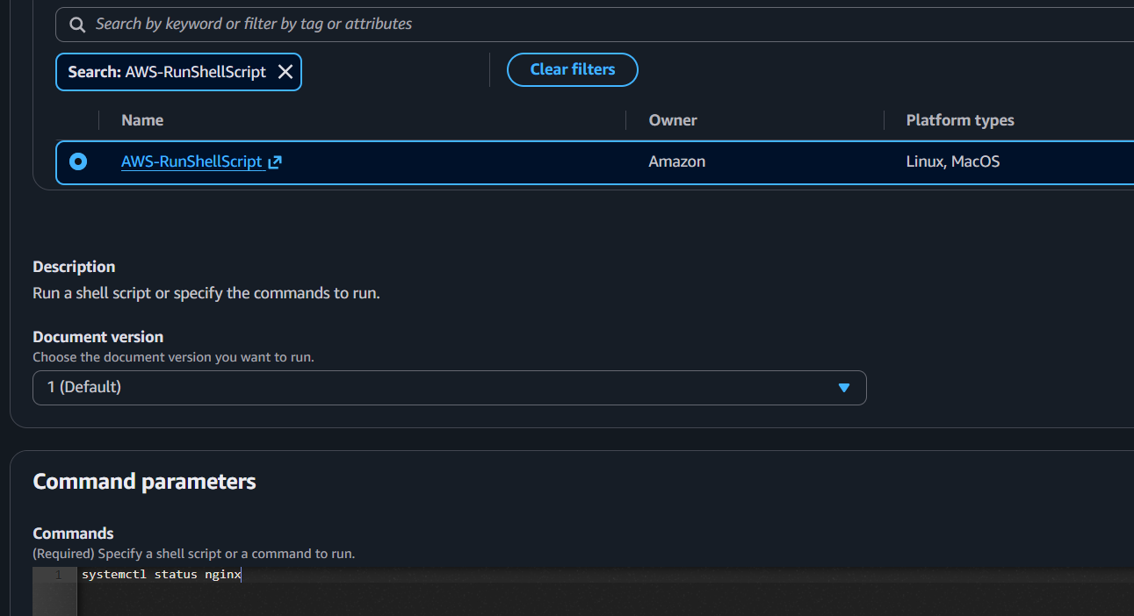

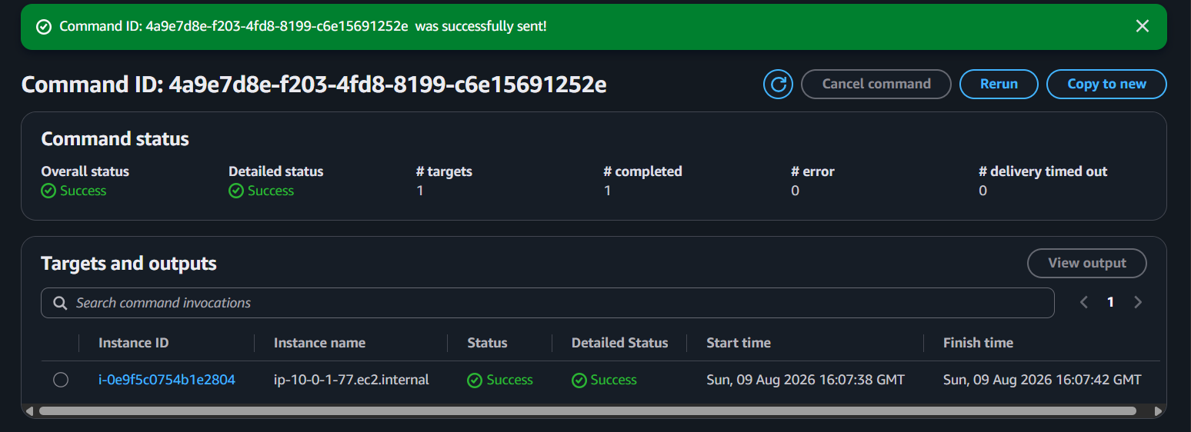
You should see:
Active: active (running)
This confirms that Nginx is running.
You can also run:
curl http://localhost
You should receive the Nginx welcome page HTML.
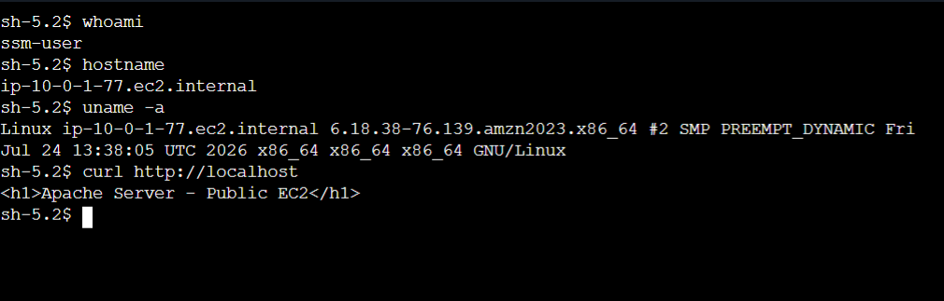

Part 10: Check EC2 Information
Now use Run Command to collect some basic server information.
Enter:
hostname
Then:
df -h
Then:
free -m
Then:
uptime
You can also execute all of them together:
echo "===== HOSTNAME ====="
hostname

echo "===== DISK ====="
df -h

echo "===== MEMORY ====="
free -m

echo "===== UPTIME ====="
uptime
Systems Manager will return the output in the AWS Console.
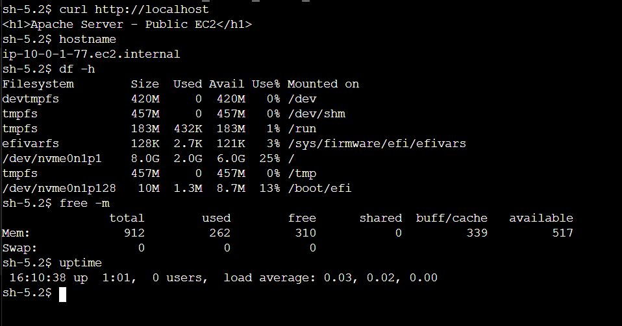

Part 11: Create a Parameter Store Parameter
Now we will use another Systems Manager feature: Parameter Store.

Step 22: Open Parameter Store
Go to:
Systems Manager → Application Management → Parameter Store
Click:
Create parameter

Step 23: Create the parameter
Use:
Name:
/movie-app/environment
Type:
String
Value:
production
Description:
Environment configuration for movie application
Then click:
Create parameter
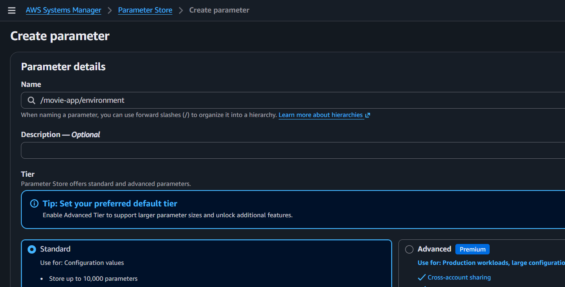
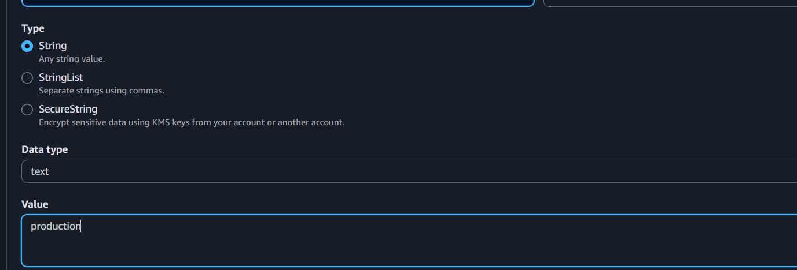
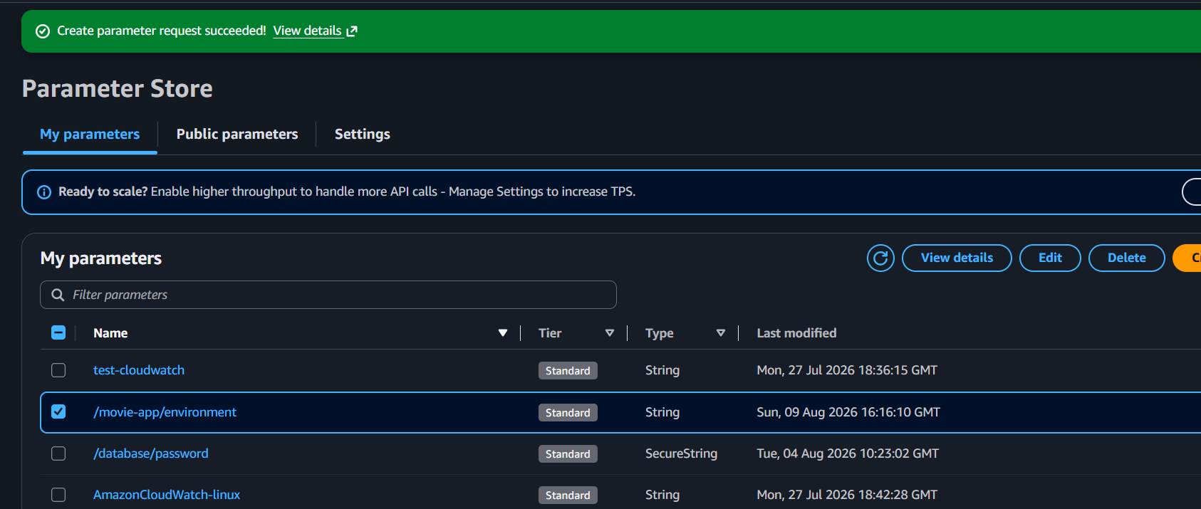

Part 12: Retrieve the Parameter
Now let's retrieve the parameter from EC2.

Step 24: Open Run Command
Go to:
Systems Manager → Run Command → Run command
Select:
AWS-RunShellScript
Run:
aws ssm get-parameter --name "/movie-app/environment"
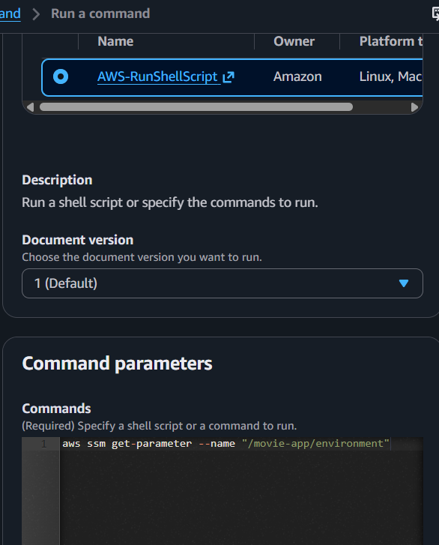

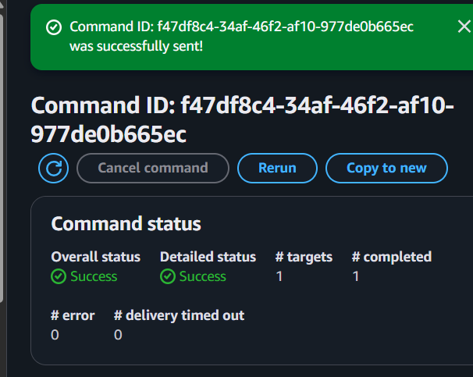

Possible problem
The AWS CLI on the EC2 instance may not have permission to read the parameter.
If you receive:
AccessDeniedException
you need to add permission to the EC2 IAM role.

Part 13: Give EC2 Permission to Read Parameter Store
Go to:
IAM → Roles → SSM-EC2-Role
Click:
Add permissions → Add permissions
You can attach:
AmazonSSMReadOnlyAccess
For a learning lab, this is simple.
For production, a more secure approach is to create a custom policy that allows access only to the required parameter.
Wait briefly for the permission to propagate.

Part 14: Test Parameter Store Again
Run:
aws ssm get-parameter --name "/movie-app/environment"
You should receive something similar to:
{
"Parameter": {
"Name": "/movie-app/environment",
"Type": "String",
"Value": "production"
}
}
You can retrieve only the value using:
aws ssm get-parameter \
--name "/movie-app/environment" \
--query "Parameter.Value" \
--output text
Expected:
Production
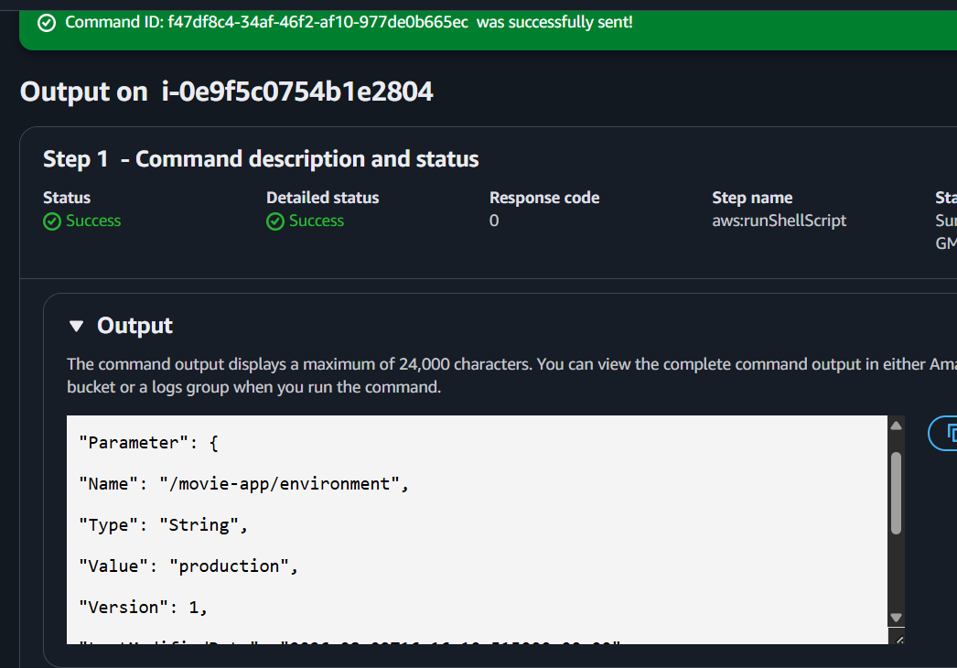
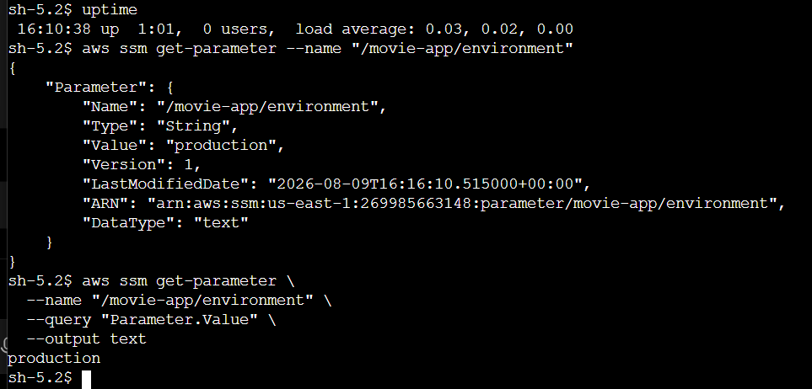

Final Architecture
AWS Console
│
▼
AWS Systems Manager
│
┌────────────────┼────────────────┐
│ │ │
▼ ▼ ▼
Session Manager Run Command Parameter Store
│ │ │
│ ▼ │
│ Install Nginx │
│ │ │
└────────────────┼────────────────┘
▼
EC2 Instance
SSM-Lab-Server
│
▼
Nginx

